**Overview**

In this exercise you will be looking to setup and configure a secondary DomainController in the Azure Landing Zone Vnet in a domaincontrollerSubnet

1. VM to be deployed into VNET: landing-zone-migration & subnet: DomainControllerSubnet
   1. No Public IP
   2. Accessible only from Hyper-V Host
2. Communication to Hyper-V VM
   1. Azure RouteTable may be required from domain controller subnet -> Gateway

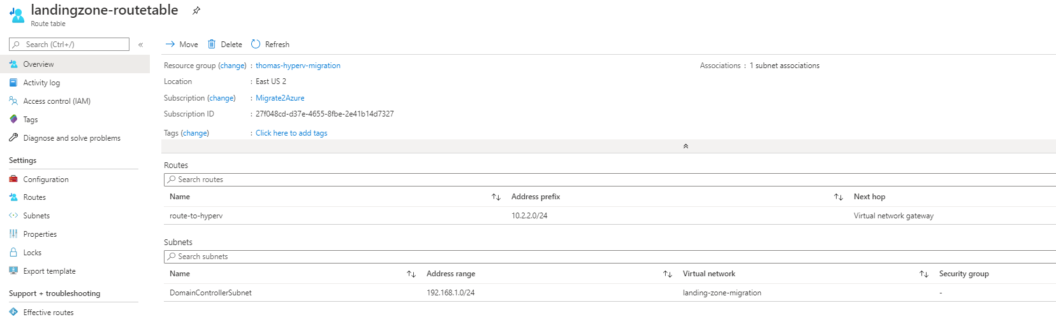

DC Promo setup (test connectivity prior to DC – VNET DNS needs to be changed temporary also – domain is kmigration.cloud)

<https://www.systemsitpro.com/2017/03/how-to-deploy-promote-and-configure.html>

<https://www.systemsitpro.com/2017/03/how-to-deploy-secondary-domain.html>

Promote secondary domain controller

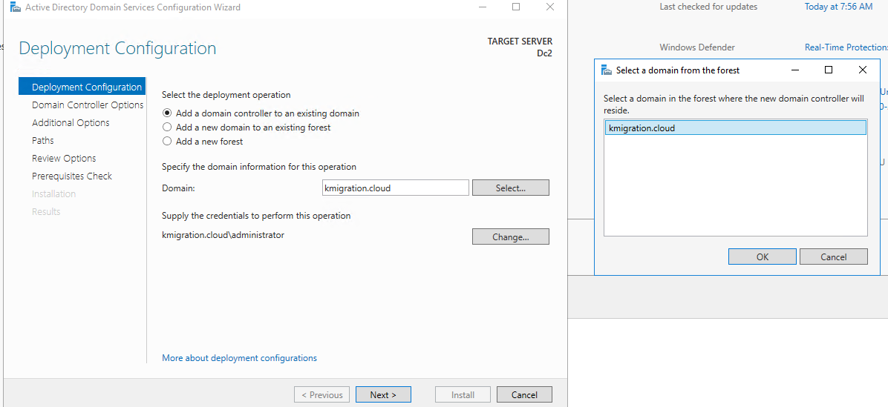

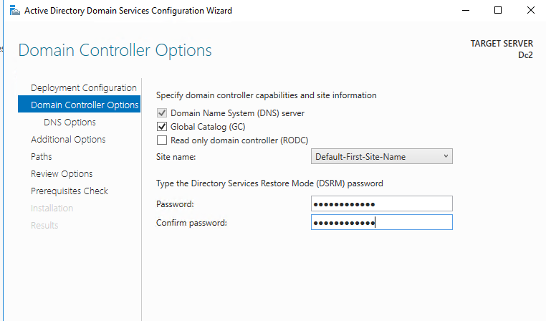

Rest of screens keep default & install

Sites & Services Setup

<https://docs.microsoft.com/en-gb/archive/blogs/canitpro/step-by-step-setting-up-active-directory-sites-subnets-site-links>

**Considerations**

* Is the subnet currently available?
* How will domainController2 VM communicate with Hyper-V domain controller?
  + What is required for communication?
  + Virtual Network DNS?

**Tasks**

1. Deploy blank VM called DC2 using Terraform/ARM/PowerShell into landing zone VM

* Deploy with no Public IP
* Access only from Hyper-V host

1. Communication/connectivity to Hyper-V VMs
2. Test connectivity
3. Promote to Secondary Domain Controller
4. Setup Domain sites and services so only Azure vNet communicates with DomainController2
5. Set VNET DNS for newly promoted DC

**Exercise completion**

1. Blank template VM deployed via Terraform/DevOps Pipeline landing zone
2. Successful DC Promo of DomainController2
3. Successful setup of domain sites and services